Respiratory System
Name
Institution
Date

Respiratory System
Anatomy, Functions, and Physiology
Anatomy
Respiration is the process of breathing in and out. Inhalation is the act of taking in oxygen, while exhalation is the process of taking out carbon dioxide. Various organs of the respiratory system are involved in breathing in oxygen and breathing out carbon dioxide. These organs are divided into upper and lower respiratory tracts. The upper respiratory tract comprises the nose, trachea, larynx, sinuses, and nasal cavity. The lower respiratory tract comprises the following organs; lungs, air sacs, bronchi, and bronchioles. Lungs are the major organs of the respiratory system. Normally, the lungs are involved in breathing in oxygen. Essentially, oxygen is needed by the cells of the body for their survival and functionality (Peate, 2018). Lungs also ensure that carbon dioxide, which is a waste product of the body cells, is removed from the body. The lungs are cone-shaped, and their tissues are spongy and pinkish gray. In the thorax, the lungs occupy the largest space, and their surrounding is a membrane called pleural.
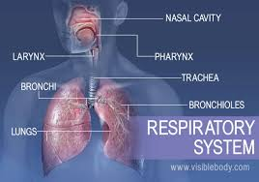
The mediastinum is the area that separates one lung from the other. The mediastinum comprises the thymus gland, heart and its vessels, trachea, lymph nodes, and esophagus. Lobes are sections of the lungs and in total the lungs have five lobes. When people breathe, the air gets into the body either through the mouth or nose; this air then moves down the throat to the larynx as well as trachea, and air moves to the lungs via the main-stem bronchi. Both the right and left lungs have a single main-stem bronchus. The main-stem bronchi are divided into minor bronchi in the lungs. The minor bronchi are further subdivided into bronchioles. The bronchioles terminate in the alveoli, where the exchange of air, both oxygen and carbon dioxide, takes place. The nasal septum divides the nose as well as the nasal cavity into two. The pharynx is a tube-shaped passage, which links the posterior nasal and oral cavities to the esophagus as well as the larynx. The pharynx is divided into laryngopharynx, nasopharynx, and oropharynx (Santacroce et al., 2020). The anatomical factors that make pharyngeal patency difficult include ineffective contraction of the muscles of the pharyngeal dilator, anatomical inequity oropharyngeal soft tissues, tracheal tug, and larynx. The sinuses are hollow spaces between the head bones, which are essential in the regulation of humidity as well as the temperature that people breathe in. The trachea is the passage that links the throat to the lungs.
From the lungs, the bloodstream moves oxygen to the other body organs and tissues. Muscles are essential because they help the movement of air that people breathe in and out of the lungs. These muscles include the diaphragm, while the bones include the ribs. The diaphragm is helpful since they assist the lungs in pulling in oxygen and pushing out carbon dioxide. The ribs are bones that form the surroundings and the protection of the lungs and the heart. The components that work in conjunction with the lungs include alveoli, bronchioles, capillaries, lung lobes, and pleura (Santacroce et al., 2020). The capillaries are blood vessels within the walls of the alveoli that aid in the movement of carbon dioxide and oxygen. Conditions that affect the respiratory system include allergies, asthma, infection, respiratory diseases, respiratory damage, and aging.
Functions
The respiratory system performs distinct functions. The major function of the respiratory system is breathing in and out oxygen and carbon dioxide, respectively. Other functions include allowing people to communicate and sense smell, delivering oxygen to the body cells, and ensuring that the airways are protected from irritants and harmful substances (Zepp& Morrisey, 2019). In addition, the respiratory system ensures that waste gases such as carbon dioxide are removed from the body through exhalation and normalizes oxygen to body temperature, and ensures its moisturization to the required levels of humidity.
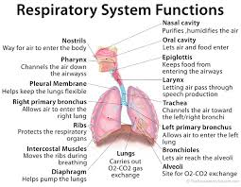
Physiology
Gas exchange is one of the major functions of the respiratory system. Normally, a gas exchange involves taking in oxygen and breathing out carbon dioxide. Oxygen is a major requirement for the process of metabolism. Although carbon dioxide is required in the body for maintaining acid-base balance, it has to be cleared out of the body. The central nervous system controls the respiratory system, despite the exchange of gases occurring in the lungs. Breathing control may be voluntary, but majorly its regulation is automatic. An injury of the brainstem and narcotic overdose suppresses breathing (Jaeger et al., 2019). The part of the central nervous system involved in respiration control is located within the medulla and the pons. The medulla and the pons are in control for nerve impulses transmitted through motor nerves, like phrenic to the intercostal muscles as well as the diaphragm. Chemoreceptors located in the brain also signify the body to regulate ventilation, and they respond in case of low oxygen levels.
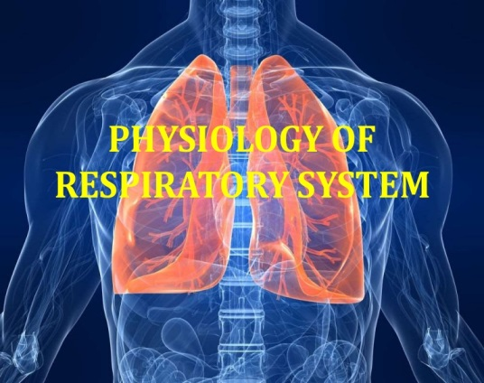
Ventilation is a major component of the respiratory system. Notably, ventilation involves the process of air movement in and out of the lungs. The factors that affect the process of ventilation include resistance to the flow of air inside the airways and lung tissue compliance as well as integrity. Around 10 to 12 times every minute, the brain send impulses to the thoracic muscles notifying them to contract (Jaeger et al., 2019). Such contraction results in the downward movement of the diaphragm while the rib cage moves up and out, increasing the thoracic cavity volume. As a result, air from the environment high pressure flows into the lungs where the pressure is low. This phase of ventilation is referred to as inhalation. The exhalation phase is characterized by relaxation of the thoracic muscles and recoiling of the lungs. As a result, the air within the lungs moves to the outside environment with low pressure. Perfusion is another component of respiration that involves blood circulation within the capillaries. The capillaries have to get an adequate blood supply in order to initiate a breathing mechanism.
Diffusion also forms part of the respiration components, and it involves a solution substance movement from higher to lower concentration areas. Diffusion is whereby oxygen is distributed from the atmosphere via the capillary walls to the bloodstream (Jaeger et al., 2019). Simultaneously, carbon dioxide is diffused from the blood to the alveoli. The diffusion process depends on factors such as the characteristics of every particular gas and perfusion rate.
Assessment of Two Organs
The selected organs are the lungs and the blood vessels. The physical exam elements for the lungs are inspection, percussion, palpation, and auscultation. When inspecting the lungs, an examiner has to pay close attention to breathing patterns such as thoracic breathing, costal markings, as well as the use of accessory muscles for breathing. Palpation is done to detect lung abnormalities, such as masses and bony crepitus. Auscultation involves an examiner using a stethoscope to listen to breathing sounds. Percussion is used with the above examination methods for effective examination of the lungs. Some of the possible lab tests for lungs include spirometry, lung volume test, pulse oximetry, and lung diffusion capacity test (Cox& Ham, 2019). A spirometry test assesses the rate of airflow and estimates the size of the lungs. A lung volume test is majorly used to measure the amount of air that can be held in the lungs. A lung diffusion test is used to evaluate the extent to which oxygen enters the bloodstream from the air that people breathe. Pulse oximetry is used to approximate the level of oxygen in the blood. Chest X-rays can be used to detect the condition of the lungs. In addition, a CT scan can help determine the possibility of lung impairment.
The physical exam elements of blood vessels include palpating arterial pulses in the neck, thighs, legs, hands, and arms, auscultation of carotid vessels, the aorta of the abdomen, subclavian and femoral arteries, assess any instances of occlusion of the arteries, measure the level of blood pressure in the arms, and inspect both upper and lower extremities (Polacheck et al., 2019). X-rays for blood vessels include angiogram, magnetic resonance angiography, and duplex ultrasound. An angiogram is a form of X-ray that is primarily used to identify any blockage within the blood vessels. Magnetic resonance angiography uses modern computerized techniques to gather complex information pertaining to blood vessels. A duplex ultrasound involves the assessment of the flow of blood into the blood vessels.
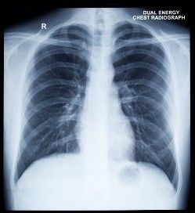
Dysfunctions
One of the dysfunctions of the lungs is lung cancer. Conversely, lung cancer is the one that affects the lungs, and it is perceived to be the leading contributor of cancer fatalities globally. The symptoms associated with lung cancer include continuous cough, breathing issues, pain in the bones, headache, unexpected loss of weight, pain in the chest, and coughing accompanied by blood. Some of the diagnostic tests for lung cancer include imaging tests, sputum cytology, and biopsy (Kraaijpoel et al., 2017). Imaging tests may include the use of X-rays and CT scans. An X-ray of the lungs may indicate the possibility of lung abnormalities like masses. A CT scan, on the other hand, can help in revealing lesions in the lungs that cannot be detected with the use of an X-ray. Sputum cytology is possible when patients have a frequent cough or producing sputum, and this helps in revealing cells of lung cancer. A biopsy involves the removal of abnormal cells in the lungs. The options for conducting a biopsy include bronchoscopy, needle biopsy, and mediastinoscopy. The treatment modalities for lung cancer include surgical operations, radiation therapy, chemotherapy, and immunotherapy. Immunotherapy is possible when cancer has not spread into other body parts and when it is not advanced. Chemotherapy involves the use of drugs either orally or intravenously. Normally, chemotherapy is used after surgical operations to kill the cells that cause cancer. Radiation therapy involves the use of energy beams to kill cells associated with cancer. Surgical operations are conducted to eliminate lung cancer.
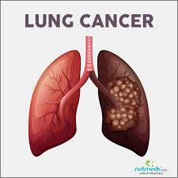
One of the dysfunctions associated with blood vessels is deep vein thrombosis (DVT). DVT transpires when blood clots form in the blood veins, especially in the lungs. The symptoms of DVT include swelling in the involved leg, pain, discoloration of the involved leg, and a feeling of warmth. The diagnostic tests available for DVT include venography, duplex ultrasound, D-dimer blood test, and MRI scan. Regarding venography, a patient is subjected to a dye injection to identify clots (Bouazza et al., 2017). Duplex ultrasound involves the use of sound waves to develop images of the flow of blood in the blood vessels. The standard test used to diagnose DVT is duplex ultrasound. D-dimer blood test is used to rule out the possibility of pulmonary embolism. For veins located in the abdomen, the physician may use an MRI scan. The treatment options for DVT include the use of blood thinners, stockings, clot busters, and filters. Blood thinners are drugs that ensure that blood clots do not grow, and they also minimize the possibility of more clots.
Nursing Management Implications
The nursing management implications for lung cancer include patient assessment, symptom management, psychological as well as counseling support, and the provision of information to both patients and families. Nurses should assess lung cancer patients in order to guide access to treatment options (Stone et al., 2017). When assessing patients, nurses should take into consideration the life of the patient and how the diagnosis would affect the patient psychologically. Nurses should also aid in the management of symptoms like breathing issues and fatigue, thereby enhancing treatment eligibility. The interventions for symptom management include the administration of drugs. Lung cancer may drain patients and family members both psychologically and emotionally, and therefore nurses should offer psychological support to patients and their families. The provision of accurate and timely information guides treatment decisions, especially where patients have prior misinformation.
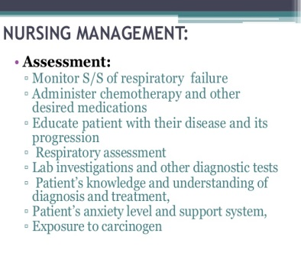
The nursing management implications for DVT include using air boots and elastic stockings, bed-resting patients to avert the dislodgement of clots, elevate the affected legs or both of them, ensure patient repositioning, especially after two hours, and make sure that the legs are not closed, ensure that vital signs are monitored every 4 to 6 hours, warm compresses to minimize swelling, and evaluate the patient regularly for complications like pain in the chest, shortness of breath, fever, and hemoptysis (Ciompi et al., 2017).

References
Bouazza, Y. B., Chiairi, I., El Kharbouchi, O., De Backer, L., Vanhoutte, G., Janssens, A., & Van Meerbeeck, J. P. (2017). Patient-reported outcome measures (PROMs) in the management of lung cancer: a systematic review. Lung Cancer, 113, 140-151.
Ciompi, F., Chung, K., Van Riel, S. J., Setio, A. A. A., Gerke, P. K., Jacobs, C., ... & Van Ginneken, B. (2017). Towards automatic pulmonary nodule management in lung cancer screening with deep learning. Scientific reports, 7(1), 1-11.
Cox, C. L., & Ham, J. (2019). Examination of the Respiratory System. Physical Assessment for Nurses and Healthcare Professionals.
Jaeger, J. M., Titus, B. J., & Blank, R. S. (2019). Essential anatomy and physiology of the respiratory system and the pulmonary circulation. In Principles and practice of anesthesia for thoracic surgery (pp. 65-92). Springer, Cham.
Kraaijpoel, N., van Es, N., Porreca, E., Büller, H. R., & Di Nisio, M. (2017). The diagnostic management of upper extremity deep vein thrombosis: a review of the literature. Thrombosis research, 156, 54-59.
Peate, I. (2018). Anatomy and physiology, 10. The respiratory system. British Journal of Healthcare Assistants, 12(4), 178-181.
Polacheck, W. J., Kutys, M. L., Tefft, J. B., & Chen, C. S. (2019). Microfabricated blood vessels for modeling the vascular transport barrier. Nature protocols, 14(5), 1425-1454.
Santacroce, L., Charitos, I. A., Ballini, A., Inchingolo, F., Luperto, P., De Nitto, E., & Topi, S. (2020). The human respiratory system and its microbiome at a glimpse. Biology, 9(10), 318.
Stone, J., Hangge, P., Albadawi, H., Wallace, A., Shamoun, F., Knuttien, M. G., ... & Oklu, R. (2017). Deep vein thrombosis: pathogenesis, diagnosis, and medical management. Cardiovascular diagnosis and therapy, 7(Suppl 3), S276.
Zepp, J. A., & Morrisey, E. E. (2019). Cellular crosstalk in the development and regeneration of the respiratory system. Nature Reviews Molecular Cell Biology, 20(9), 551-566.

